# Lab: CSS Styling

Problems for exercises and homework for the "IT Basics HTML and CSS" course from the official" Applied Programmer" curriculum.

You can check your solutions here: <https://judge.softuni.bg/Contests/2970/CSS-Styling-Lab>.

## Restaurant Menu

Create a web page like the following:

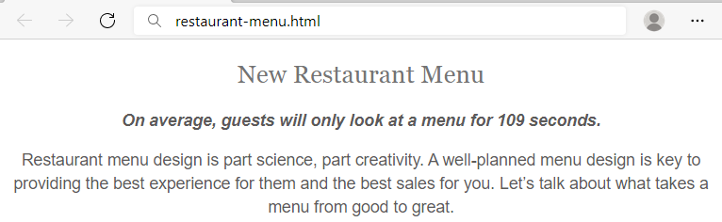

### Constraints

HTML with <body> that contains: <article>, <h1>, <span> and <p>.

CSS:

* <body>:
  + Align the **text** to the **center**
* <h1>:
  + Fonts: **Sentinel** **A**, **Sentinel** **B**, **Georgia**, **Times** **New** **Roman**, **Times**
  + Generic Font: **serif**
  + Font weight **400**
  + Height of the line: **1.15**
  + Text color: #**747474**
  + All characters to be **UPPERCASE**
* <span>:
  + Fonts: **Graphik** **Semibold** **Web**, **Open** **Sans**, **Helvetica** **Neue**, **Helvetica**, **Arial**
  + Generic Font: **sans-serif**
  + Font style: **oblique**
  + Font weight: **600**
  + Font size: **16px**
  + Height of the line: **1.46**
  + Text color: **#5c5a5a**
* <p>:
  + Fonts: **Graphik** **Regular** **Web**, **Helvetica** **Neue**, **Helvetica**, **Arial**
  + Generic Font: **sans-serif**
  + Font weight **400**
  + Font size: **16px**
  + Height of the line: **1.46**
  + Text color: **#5c5a5a**

## Font Awesome Icons

Create a web page like the following:

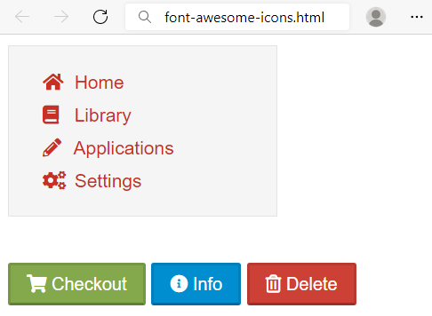

### Constraints

HTML with <body> that contains: <nav> and separately <p>.

* <nav> with
  + <ul> and in it
    - <li> and in it
      * <a> and in it
        + <i> + text
* <p> with three buttons
  + <button> with class="shopping"
  + <button> with class="info"
  + <button> with class="delete"

CSS:

* Import font awesome link
* <body>:
  + Fonts: **proxima-nova**, "**Helvetica** **Neue**", **Helvetica**, **Arial**
  + Generic Font: **sans-serif**
* <nav>:
  + Width: 200px
  + Solid border with size 1px and color #e3e3e3
  + Font size: **14px**
  + Height of the line: 20px
  + Background color: #f5f5f5
* <li>:
  + None list style
  + Height of the line: 25px
  + Left margin: -15px
* <a>:
  + None text decoration
  + Text color #c83025
* <i>:
  + Width: 1.14em
  + Right padding: 0.28em

For all the **buttons**:

* **Top** & bottom padding 4px
* **Left** & **right** padding 12px
* Height of the line: 20px
* Text color: #ffffff
* Border color: rgba(0, 0, 0, 0.1) rgba(0, 0, 0, 0.1) rgba(0, 0, 0, 0.25)
* Cursor: pointer

For the **button.shopping**:

* Background color: **#83a94c**

For the **button.info**:

* Background color: **#008ed0**

For the **button.delete**:

* Background color: **#cc4036**

## Scrolling Article

Create a web page like the following:



### Constraints

HTML with <body> that contains: <section> with <article> which has <h2>, <h3> and <p>.

CSS:

* <article>:
  + Width: **500px**
  + Height: **200px**
  + Background color: **lightgray**
  + Paddings: **10px**
  + **Auto** overflow
* <h2>:
  + All characters to be **UPPERCASE**
  + Align the **text** to the **center**
* <h3>:
  + Align the **text** to the **center**
* <p>:
  + Indent text in the first line 30px

## Brazil Coffee

Create a web page like the following:

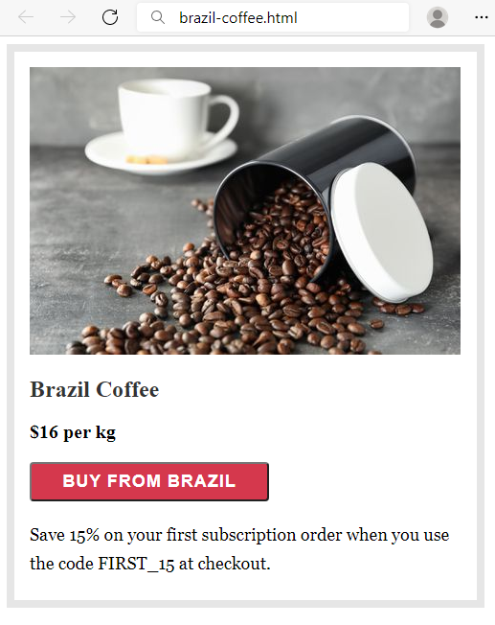

### Constraints

HTML with <body> that contains: <section> which has <img>, <h2>, <div>, <button> and <p>.

CSS:

* <section>:
  + Solid border with size 8px and color #e6e6e6
  + Paddings: **16px**
  + Width: **451px**
  + Height: **540px**
* <h2>:
  + Font: **Merriweather**
  + Generic Font: **serif**
  + Font weight **700**
  + **Top** & bottom margin 1.2rem
  + **Left** & **right** margin 0
* <div>:
  + Font weight **600**
  + Font size: **20px**
* <button>:
  + Width: **250px**
  + Font : **Work Sans**
  + Generic Font: **sans-serif**
  + Font weight **600**
  + Font size: **18px**
  + Border radius: **4px**
  + Background color: #**d5384d**
  + Text color: **#fff**
  + Letter spacing: **1px**
  + Align the **text** to the **center**
  + **Top** & bottom padding 8px
  + **Left** & **right** padding 16px
  + Top margin: **20px**
  + Bottom margin: **20px**
* <p>:
  + Fonts: **Georgia**, **Cambria**, **Times** **New** **Roman**, **Times**
  + Generic Font: **serif**
  + Font size: **18px**
  + Height of the line: 30px
  + Top margin: **0**

## Floating Images

Create a web page like the following:

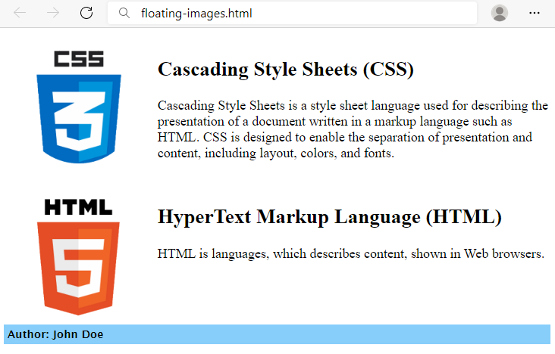

### Constraints

HTML with <body> that contains: two <article> and <footer>.

* <article> with
  + <img>
  + <h1>
  + <p>
* <footer> with
  + <div>

CSS:

* <article>:
  + Font size: **20px**
  + Padding: **10px**
  + Clear the **float**
* <img>:
  + Width: **200px**
  + Height: **200px**
  + Right padding: **15px**
  + Float the images on the **left**
* <footer>:
  + Generic Font: **sans-serif**
  + Font weight **600**
  + Paddings: 5px
  + Background color: lightskyblue
  + Clear the **float**

## New Offer

Create a web page like the following:

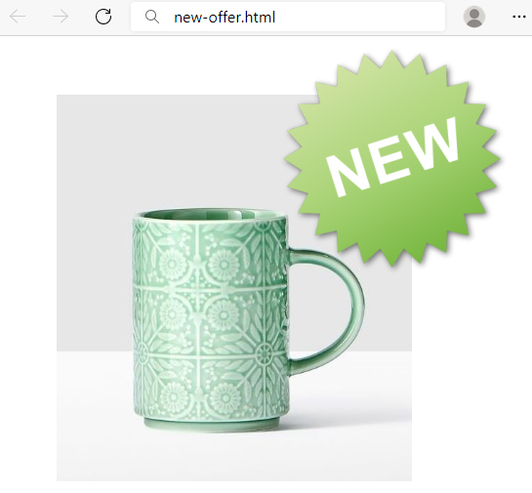

### Constraints

HTML with <body> that contains <main> and two <img>.

<img> with new.png need class="new".

CSS:

* <main>:
  + Width: **700px**
  + Height: **500px**
  + Margins: **60px**
* img.new:
  + **Relative** position
  + Top coordinates: **-200px**
  + Right coordinates: **150px**

## Interior Design Studio

Create a webpage like the following:

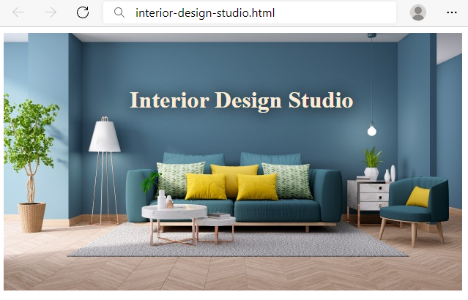

### Constraints

HTML with <body> that contains <h1> and <img>.

CSS:

* <h1>
  + **Absolute** position
  + **Top** coordinates: **60px**
  + **Left** coordinates: **180px**
  + Text color: **antiquewhite**
  + text-shadow: 1px 1px 20px black;